1. Your task is to examine data found at the Bureau of Labor web site, and answer the question: “What are the five best professions for the college class of 2024?” (see paragraph 7 for additional detail). Note that you will decide the criteria for “best profession”, and will later state it. It does not have to be “best pay”. You decide what determines “best”.
2. You must support your choice with evidence from the web site and from at least one other equally reputable web site. You will summarize your evidence in a power point.
3. Please go to web location <http://www.bls.gov/data>
4. Select “Employment Projections”
5. Select “Occupational Projections Data”, then the “One-Screen Data Search” ICON
6. You now have several choices as shown in Figure 1. Pick one, then click the “Submit” button.

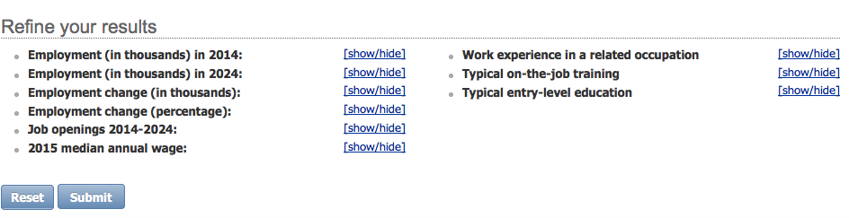

Figure 1. Selection Options

1. Now find five (or more) occupations (rows) in the selected table and examine column entries for those occupations. Up to four should be in computing fields, at least one must be in a non-computing field.
2. Copy numeric data into an Excel spreadsheet, then use Excel to prepare a graphical display (bar chart, pie chart, etc.) of the data.
3. After making your choice of five
   1. Find at least one other web site that adds additional data about the chosen occupations; extract some information from this for your power point.
   2. You may work with one other classmate on this, assuming you can agree on five choices
   3. Create a power point (less than 10 slides) that describes your five choices, the evidence you used to select them, and additional detail about at least the top three choices.